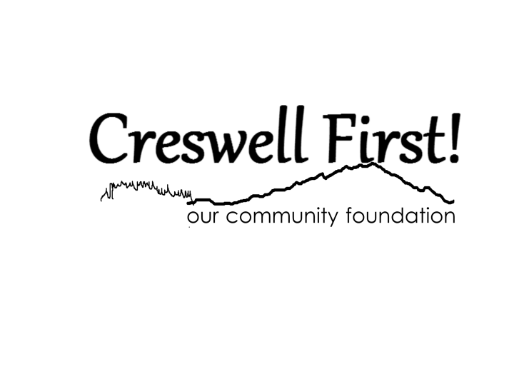

|  |  |
| --- | --- |
| *For Internal Use Only* | |
| *Date Rcd* |  |
| *Time Rcd* |  |
| *Rcd by* |  |
| *Complete?* | Y    N |

P.O. Box 1

Creswell, OR 97426

[creswellfirst@creswellfirst.com](mailto:creswellfirst@creswellfirst.com)

Tax-ID: 47-3064430

**Community Services 2024 Funding Application**

***Submission Deadline is 4:00 pm November 30. 2023***

Applications shall be a maximum of five (5) pages~~.~~

|  |  |  |
| --- | --- | --- |
| Today’s Date: | | |
| Organization Name: | | |
| Address: | | |
| City: | Zip: | State: |
| Contact Person Name: | | Title: |
| Phone: | Email: | |

I certify that the submitted information is correct and that I am authorized by the governing board of this organization to submit this request for funding to Creswell First!

Signature: ______________________________________________ Title: _______________________

(Signature if postal mail submission, Typed if email submission)

|  |
| --- |
| Project Title |
| Total Funding Requested from Creswell First!: |
| Briefly describe the goals for the project. |
| Describe the need in Creswell you will be addressing with the project. |
| What experience does your organization have in addressing this need? |
| What is your timeline for the project? |
| Please provide budget information: How will the funds be utilized |
|  |
| Provide any other information that you would like: |