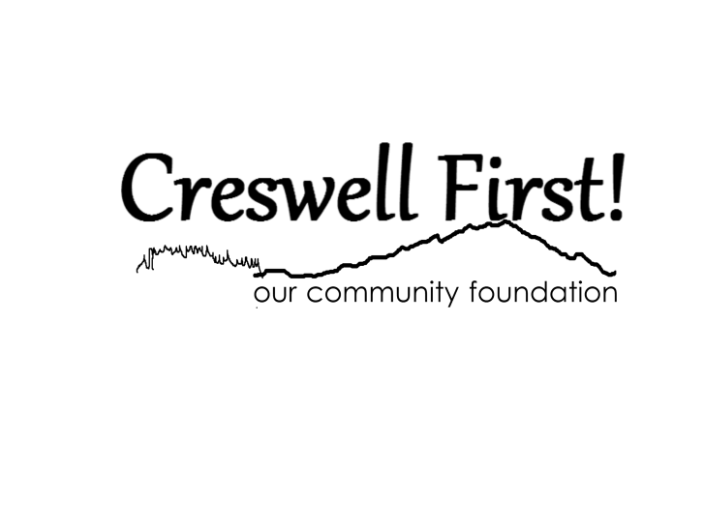P.O. Box 646

Creswell, OR 97426

[creswellfirst@creswellfirst.com](mailto:creswellfirst@creswellfirst.com)

Tax-ID: 47-3064430

**Creswell First Foundation Special Project Application**

Dear Creswell First Foundation Applicant:

Thank you for your interest in partnering with Creswell First! To get started, please complete and submit the enclosed application. This will help the CF! board fully understand your project and to reach a determination regarding alignment with our mission and values.

**Mission**: Connecting people who care with causes that matter for the betterment of Creswell.

**Values**:

* Respect for all people
* Commitment to innovation and effectiveness
* Flexibility and the capacity to think big
* Cultivation of opportunities for positive impact
* Collaboration, not competition

We look forward to reviewing your application and exploring how we might partner to better Creswell! Scheduling a meeting with us before submission is encouraged. Please email for availability. Thank you.

Please type into the fields below. Submitted application must be no longer than four pages. You will have an opportunity to meet with a Board representative and may share additional information at that time.

|  |  |  |  |  |
| --- | --- | --- | --- | --- |
| **Project name** |  | **Date of application** | |  |
| **Contact person** |  |  | |  |
| **Phone** |  | **Email** |  | |

**Purpose of project:**

How will the project benefit the Creswell Community?

|  |
| --- |
|  |

**Fundraising goal:**

Please describe what you can foresee of your fundraising needs, goals, and ideas.

|  |
| --- |
|  |

**Timeline:**

Is the project ongoing, annual, or one-time only?

|  |
| --- |
|  |

**Background of project**:

Explain the need, what research has been done, and what funds are already in place.

|  |
| --- |
|  |

**Location of project**:

Is the project located within Creswell School District Boundaries? If not, where is it located?

|  |
| --- |
|  |

**Long-term goal of project**:

How will the project be sustainable? Who will care for and fund the maintenance?

|  |
| --- |
|  |

**Why are you applying to Creswell First!?**

How and why do you think Creswell First! will help make your project successful?

|  |
| --- |
|  |

**Submission Instructions**

Mail or email completed application to:

P.O. Box 646

Creswell, OR 97426

[creswellfirst@creswellfirst.org](mailto:creswellfirst@creswellfirst.org)

(Email is preferred)